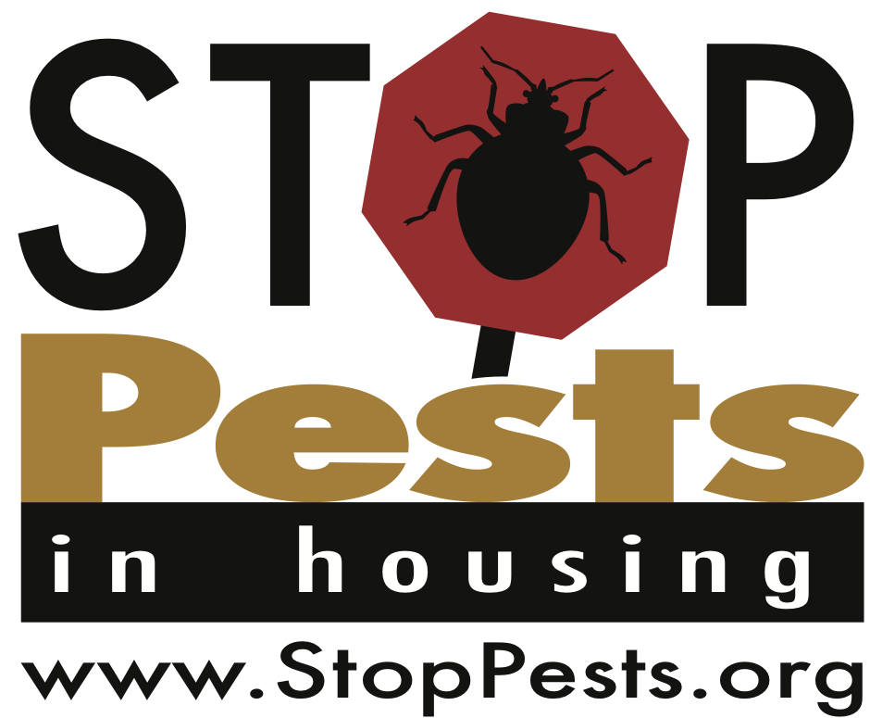
For Landlords
Gain background knowledge/resource ideas:
- Read “IPM: A Guide for Affordable Housing” (available at www.stoppests.org/Guide)

- Read through the resources/watch the videos available at www.stoppests.org/pest-solutions/bed-bugs/
Adopt enforceable policy
- Model language for bed bugs: www.stoppests.org/stoppests/assets/File/Affordable%20Housing%20Bed%20Bug%20Plan.doc

- Model language for housekeeping/general pest: www.stoppests.org/what-is-ipm/using-ipm/#policy
Dedicate staff time to preventative measures
- Monitors for crawling pests placed and maintained

- Residents educated on their role in pest control (www.stoppests.org/working-with-residents/)

  - Move-in
  - In lobbies
  - Remediation classes
  - Other:

- Housekeeping inspections 30-90 days after move-in and annually thereafter

- Staff person accompanies the pest management professional on each visit

- Housekeeping failure process
Network with local service providers
- Complete a “OneTouch” sheet
- NYS IPM Program: www.nysipm.cornell.edu
Template OneTouch Reference Sheet
Use this reference sheet to put families in touch
with the support they may need.

Family Need | Support Agency | Contact Information
Asthma
Asbestos
Carbon Monoxide
Family & Parent Support/Elderly Services
Fire Safety
Housing Code Violations
Injury Prevention
Lead
Housing Relocation Services
Moisture & Mold
Small Repairs
Pest Control | NYS IPM Program  National Pesticide Information Center  StopPests in Housing  Local extension | www.nysipm.cornell.edu  www.npic.orst.edu  800-858-7378  www.StopPests.org  www.nifa.usda.gov/Extension/
Radon
Smoking Cessation
Weatherization
Head Start

To suggest family needs or references, contact:____________________________________________

